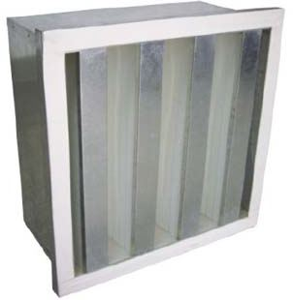 **V-BANK HEPA FILTER**

Product Description: High efficiency filter that can capture

particles about 99.99% @ 0.3 µm and has airflow that can reach

4200 m3/h.

Application: Aviation, electronic, semiconductor, wafer,

Biological pharmaceutical, hospital, food processing, etc.

**Technical Specifications**

|  |  |
| --- | --- |
| Type | 3-6 banks |
| Media | Glass Fiber |
| Frame | Aluminum/Stainless/G.I./Plastic |
| Efficiency | 99.99-99.995% @ 0.3 µm |
| Class | H10-H14 |
| Max. Temp. | 70°C |

|  |  |  |  |  |  |
| --- | --- | --- | --- | --- | --- |
| Size  (L x W x T mm**)** | Airflow  (m3/h) | Initial DP  (Pa) | Final DP  (Pa) | Filtering Area  (m2) | Dust Holding  Capacity (g) |
| 285x285x292 | 600 | 350 | 400-600 | 5.42 | 325 |
| 592x592x292 | 1770 | 350 | 400-600 | 16.43 | 986 |
| 592x592x292 | 2400 | 350 | 400-600 | 21.91 | 1315 |
| 610x610x292 | 3200 | 350 | 400-600 | 28.2 | 1692 |
| 915x610x292 | 4000 | 350 | 400-600 | 33.84 | 2031 |
| 484x484x292 | 1460 | 350 | 400-600 | 13.51 | 811 |
| 610x305x292 | 1500 | 350 | 400-600 | 14.44 | 866 |
| 630x630x292 | 3100 | 350 | 400-600 | 29.11 | 1746 |
| 600x600x292 | 3000 | 350 | 400-600 | 27.75 | 1665 |
| 570x570x292 | 2300 | 350 | 400-600 | 21.12 | 1267 |
| 515x515x292 | 2100 | 350 | 400-600 | 19.13 | 1148 |
| 610x484x292 | 2450 | 350 | 400-600 | 22.52 | 1351 |

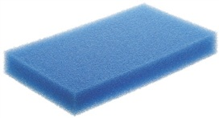

**PORET FILTER(EMW FILTERTECHNIK)**

Product Description: Poret filter foam is a high quality

open cell foam that removes debris with high chemical

stability and long life.

Applications: Air filtration, mist eliminators, pond and

Aquarium filters, air humidifier matting, water distribution, etc.

**Technical Specification**

|  |
| --- |
| Air filtration |
| Contain no plasticizers |
| High ozone and oxygen resistance |
| Temperature resistant up to 90°C |
| CFC-free foaming process |
| Recyclable |
| Easy disposal by Thermal Recycling |

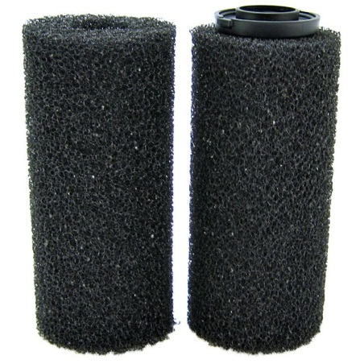**PORET CARBON FILTER**

Product Description: Poret Carbon Filter is impregnated

with highly active carbon powder, granules or pellets.

Approx. 80-100 grams of activated carbon are impregnated

per millimeter of material thickness and m² of foam,

providing a specific surface area of 900-1300 m²/g.

Applications: Heating, ventilation, air Conditioning (HVAC),

Laboratories, dust/fume removal hoods at workplaces and

Odor absorbers.

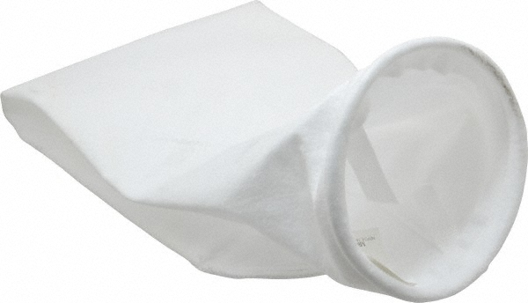

**PP MICRON BAG**

Product Description: Provides outstanding performance

for applications requiring higher filtration efficiency.

Application: Food, Beverage, Water and Chemical Applications.

**Technical Specifications**

**PP5**

|  |  |  |
| --- | --- | --- |
| Model Number | PP5 | |
| Composition | Fiber | 100% PP Virgin Fiber |
| Scrim | Self-supported |
| Weight (g/m²) | 450 | |
| Thickness (mm) | 2.6 | |
| Density (g/cm³) | 0.17 | |
| Air Permeability (L/dm².min) | 25-36m³/m².min @ 200pa | |
| Pore Volume (%) | 86 | |
| Tensile Strength  (N/5x20cm) | Warp | >600 |
| Weft | >1000 |
| Elongation  At break (%) | Warp | <60 |
| Weft | <60 |
| Temp. Resistance (°C) | Continuous: <90; peak: 95. | |
| Surface Design/treatment | Singed and glazed face side | |

**PP10**

|  |  |  |
| --- | --- | --- |
| Model Number | PP10 | |
| Composition | Fiber | 100% PP Virgin Fiber |
| Scrim | Self-supported |
| Weight (g/m²) | 370 | |
| Thickness (mm) | 2.2 | |
| Density (g/cm³) | 0.17 | |
| Air Permeability (L/dm².min) | 50-70m³/m².min @ 200pa | |
| Pore Volume (%) | 86 | |
| Tensile Strength  (N/5x20cm) | Warp | >500 |
| Weft | >800 |
| Elongation  At break (%) | Warp | <80 |
| Weft | <80 |
| Temp. Resistance (°C) | Continuous: <90; peak: 95. | |
| Surface Design/treatment | Singed face side | |

**PP25**

|  |  |  |
| --- | --- | --- |
| Model Number | PP25 | |
| Composition | Fiber | 100% PP Virgin Fiber |
| Scrim | Self-supported |
| Weight (g/m²) | 360 | |
| Thickness (mm) | 2.3 | |
| Density (g/cm³) | 0.16 | |
| Air Permeability (L/dm².min) | 60-90m³/m².min @ 200pa | |
| Pore Volume (%) | 86 | |
| Tensile Strength  (N/5x20cm) | Warp | >500 |
| Weft | >800 |
| Elongation  At break (%) | Warp | <85 |
| Weft | <85 |
| Temp. Resistance (°C) | Continuous: <90; peak: 95. | |
| Surface Design/treatment | Singed face side | |

**PP50**

|  |  |  |
| --- | --- | --- |
| Model Number | PP50 | |
| Composition | Fiber | 100% PP Virgin Fiber |
| Scrim | Self-supported |
| Weight (g/m²) | 380 | |
| Thickness (mm) | 2.3 | |
| Density (g/cm³) | 0.17 | |
| Air Permeability (L/dm².min) | 85-110m³/m².min @ 200pa | |
| Pore Volume (%) | 86 | |
| Tensile Strength  (N/5x20cm) | Warp | >500 |
| Weft | >600 |
| Elongation  At break (%) | Warp | <85 |
| Weft | <85 |
| Temp. Resistance (°C) | Continuous: <90; peak: 95. | |
| Surface Design/treatment | Singed face side | |

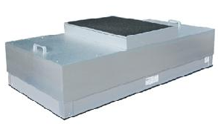**FAN FILTER UNIT**

Product Description: Used to supply purified air to

cleanrooms or microenvironments by filtering out harmful

airborne particles from recirculating air with 99.99%

efficiency @ 0.3 µm.

Application: Individual workplaces, Cleanroom ceilings.

**Technical Specifications**

|  |  |
| --- | --- |
| Filter | Mini-pleat/Disposable Prefilter and HEPA filter cartridge |
| Frame | Aluminum Frame/Stainless Steel |
| Efficiency | 99.99% @ 0.3 µm |
| Size | 24”x48”x11½” |

**Fan Motor**

|  |  |
| --- | --- |
| Motor: | EBM Motors (Made in Germany) |
| Input Power: | 120W |
| Average Face Velocity: | 900cfm |
| Electrical Requirement: | 220V/60Hz/1ph |
| Blower Type: | Backward Inclined Blower |
| Max. Air Volume: | 2365m³/h |
| Max. Pressure: | 300 Pa |

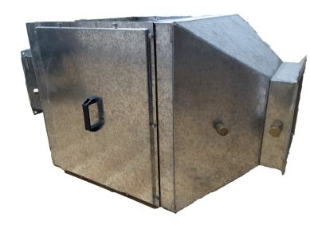**FILTER BOX**

Product Description: Box-type structure, rugged construction

With large dust capacity and high flow rate and efficiency.

Standing flanges provided to mate housing to other housing

or ductwork. Weatherproof housing without modification.

Housing will be provided with pin-hinged removable

Access doors for service from either side of the housing.

Also, absolute filter housing will be all-welded construction

Of 14-gauge galvanized steel.

Application: Machinery, Electronics, Precision Instruments,

Food Industry and General Air Conditioning and Ventilation

Systems intermediate filtration.

**Technical Specifications**

|  |  |
| --- | --- |
| Frame | Aluminum/G.I./Stainless |
| Size | Customizable |

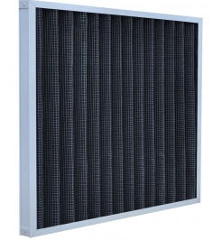**ACTIVATED CARBON FILTER**

Product Description: Good Deodorization effect that has

>70% odor remove rate and long service life.

Applications: Airports, subways, cars, electronics factories,

Nuclear power plants, household and central

Air conditioning, hospitals, sewage treatment.

**Technical Specifications**

|  |  |
| --- | --- |
| Type | Panel/Pleated |
| Media | Activated Carbon Filter |
| Frame | Aluminum/Stainless Steel/G.I. |
| Efficiency | >70% |
| Class | G2 |
| Max. Temp. | 80°C |

|  |  |  |  |  |
| --- | --- | --- | --- | --- |
| Size  (L x W x T mm) | Airflow  (m3/h) | Initial DP  (Pa) | Filtering Area  (m2) | Odor Removal Rate (>) |
| 592x592x21 | 1150 | 40 | 0.90 | 70% |
| 287x592x21 | 550 | 40 | 0.47 | 70% |
| 490x592x21 | 970 | 40 | 0.77 | 70% |
| 592x592x46 | 1200 | 40 | 0.97 | 70% |
| 287x592x46 | 650 | 40 | 0.52 | 70% |
| 490x592x46 | 1080 | 40 | 0.86 | 70% |
| 495x295x21 | 504 | 40 | 0.4 | 70% |
| 610x610x46 | 1339 | 40 | 1.06 | 70% |
| 495x495x21 | 840 | 40 | 0.67 | 70% |
| 295x295x46 | 327 | 40 | 0.26 | 70% |
| 495x295x46 | 544 | 40 | 0.43 | 70% |
| 495x495x46 | 907 | 40 | 0.72 | 70% |

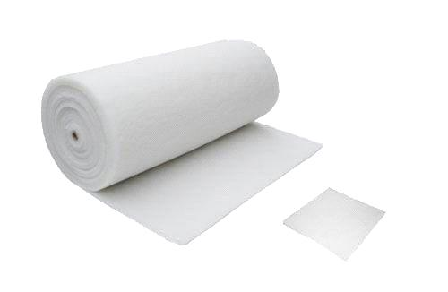**CEILING FILTER**

Product Description: High-level Ceiling Filter

for paint-spray systems. Filter mat could also be used

for fine filtration in all kinds of Ventilation systems and units.

Applications: Widely used in spray booths

**Technical Specifications**

|  |  |
| --- | --- |
| Type | Dry/Sticky |
| Media | Fiber Glass |
| Efficiency | 50% |
| Class | F5 |
| Max. Temp. | 100°C |

|  |  |
| --- | --- |
| Weight (g/m²) | 600 |
| Thickness (mm) | 22 |
| Relative Humidity | 100% |
| Arrestance | 97.1% |
| Nominal Media Velocity (m/s) | 0.25 |
| Initial Pressure Loss Pa(mmag) | 35 (3.5) |
| Recommended Final Pressure Loss Pa(mmag) | 400 (40) |
| Dust holding capacity g/m² | 317 |

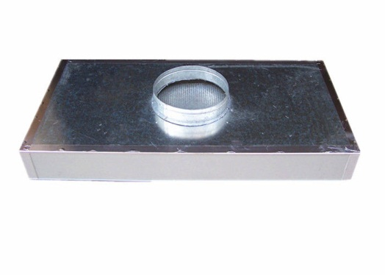**HEPA CEILING FILTER**

Product Description: HEPA filter media provides high purity air

with extremely low turbulences in the air flow. High quality,

wet layed glass fiber media is used for these filters.

Applications: Clean rooms, Laboratories, Clean room work benches,

Air intake at work stations.

**Technical Specifications**

|  |  |
| --- | --- |
| Type | Terminal HEPA Filter (Ceiling Module) |
| Media | Fiber Glass |
| Frame | Aluminum/G.I./Stainless Steel |
| Efficiency | 99.97-99.995% |
| Class | H10-H14 |
| Max. Temp. | 80°C |

|  |  |  |  |  |  |  |  |
| --- | --- | --- | --- | --- | --- | --- | --- |
| Type | Dimension  (mm) | Air Flow  (m³/h) | Pressure Loss (Pa) | | | | |
| H10 | H11 | H12 | H13 | H14 |
| RS 66 | 305X305 | 150 | 50 | 80 | 120 | 135 | 158 |
| RS 66 | 305X610 | 300 | 50 | 80 | 120 | 135 | 158 |
| RS 66 | 305X762 | 375 | 50 | 80 | 120 | 135 | 158 |
| RS 66 | 610X610 | 600 | 50 | 80 | 120 | 135 | 158 |
| RS 66 | 610X762 | 750 | 50 | 80 | 120 | 135 | 158 |
| RS 66 | 610X915 | 900 | 50 | 80 | 120 | 135 | 158 |
| RS 66 | 610X1220 | 1200 | 50 | 80 | 120 | 135 | 158 |
| RS 66 | 610X1525 | 1500 | 50 | 80 | 120 | 135 | 158 |
| RS 66 | 762X762 | 940 | 50 | 80 | 120 | 135 | 158 |
| RS 66 | 762X915 | 1120 | 50 | 80 | 120 | 135 | 158 |
| RS 66 | 762X1220 | 1500 | 50 | 80 | 120 | 135 | 158 |
| RS 66 | 915X915 | 1330 | 50 | 80 | 120 | 135 | 158 |
| RS 66 | 915X1220 | 1800 | 50 | 80 | 120 | 135 | 158 |

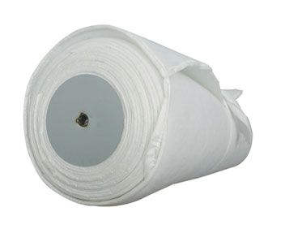**AUTO ROLL FILTER**

Product Description: Designed to replace the original equipment

filter.

Applications: Ventilation system of spray booths, primary filtration

in air conditioning systems.

**Technical Specification**

|  |  |
| --- | --- |
| Application | Ventilation system of spray booths, primary filtration in air conditioning systems |
| Material | Glass Fiber or Synthetic |
| Type | Rigid backing (for high air volume), non-rigid backing (can be cut) |
| Uses | 1. Glass Fiber Auto Roll Media: Major automatic roll filter.  2. Synthetic Fiber Auto Roll Media: Major automatic roll filter units utilizing synthetic fiber |
| Thickness | 1”, 2” |
| Average Efficiency | 97% (weight method) |
| Max. Temp. | 100°C |
| Air Velocity | 0.25m/s |
| Dust Holding Capacity | 310g/m |
| Final Pressure Drop | 450 Pa |
| Inflammability | DIN53438-1/K-1 |
| Initial Pressure Drop | 35 Pa |

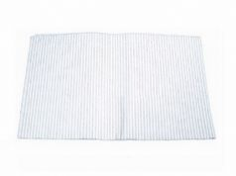**OVEN FILTER (NIPPON MUKI)**

Product Description: The product is made of glass fibers in

Different diameters and fitted in meshed aluminum sheet frame.

It has advantages of high temperature resistance, high efficiency,

Low resistance and ease of installation.

Applications: Used for automobile and household appliance coating

And various hot air ovens, coating equipment and air conditioning

Systems where are air cleaning is needed. Intake and circulating

Air filtration spray booths and car painting line.

**Technical Specification**

|  |  |  |
| --- | --- | --- |
| Grade and Thickness | 40mm | 80mm |
| Rated Airflow | 950m³/h | 900m³/h |
| Initial Resistance | 90Pa | 120Pa |
| Final Resistance | 250Pa | 250Pa |
| Filter Class | G4 | F5 |
| The Max. Size | 500*500mm | 500*500mm |
| Temp. Resistance | 300°C | 300°C |

**OVEN FILTER (SHW)**

Product Description: Heat Resistant, High Airflow, Low Resistance

Applications: Electronics, Military Aerospace Coating Area,

High-Temperature Oven

**Technical Specification**

|  |  |
| --- | --- |
| Rated Airflow | 900m³/h |
| Ave. Arrestance | 86% |
| Working Temp. | 250°C |
| Initial Pressure Drop | 40 Pa |
| Final Pressure Drop | 180 Pa |

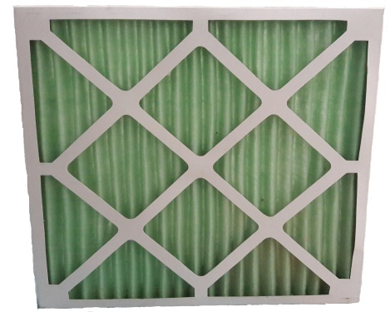**DISPOSABLE PREFILTER**

Product Description: Moisture resistant 100% synthetic media

Convenient replacement, strong structure, low resistance

and high dust holding.

Application: Air Handling Units, Offices, Buildings

Industrial and Clean Room Applications

**Technical Specifications**

|  |  |
| --- | --- |
| Type | Pleated Media with welded wired support |
| Media | Synthetic Fiber |
| Frame | Cardboard/Aluminum/G.I./Stainless |
| Efficiency | 30% ~ 35% and 40% ~ 45% |
| Class | G3/G4 |
| Max. Temp. | 80 0C |

|  |  |  |  |  |  |  |
| --- | --- | --- | --- | --- | --- | --- |
| Size  (L x W x T mm) | Airflow  (m3/h) | Initial DP  (Pa) | Final DP  (Pa) | Filtering Area  (m2) | Dust Holding Capacity (g) | Efficiency |
| 592 X 592 X 10 | 2500 | 30 | 100 – 200 | 0.37 | 50 | G2 |
| 592 X 592 X 10 | 2500 | 40 | 100 – 200 | 0.37 | 60 | G3 |
| 592 X 592 X 10 | 2500 | 45 | 150 – 250 | 0.37 | 75 | G4 |
| 592 X 287 X 10 | 1200 | 30 | 100 – 200 | 0.19 | 25 | G2 |
| 592 X 287 X 10 | 1200 | 40 | 100 – 200 | 0.19 | 30 | G3 |
| 592 X 287 X 10 | 1200 | 45 | 150 – 250 | 0.19 | 40 | G4 |
| 490 X 490 X 10 | 1700 | 40 | 100 – 200 | 0.26 | 40 | G3 |
| 490 X 490 X 10 | 1700 | 45 | 150 – 250 | 0.26 | 55 | G4 |
| 592 X 592 X 21 | 2500 | 25 | 100 – 200 | 0.37 | 40 | G2 |
| 592 X 592 X 21 | 2500 | 40 | 100 – 200 | 0.37 | 75 | G3 |

*Non-standard sizes are also available.

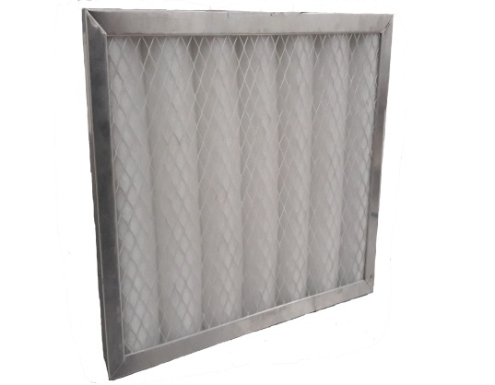**PRIMARY WASHABLE FILTER**

Product Description: Washable primary filter for

low efficiency filtration

Application: Air Handling Units, Offices, Buildings,

Industrial and Clean Room Applications

**Technical Specifications**

|  |  |
| --- | --- |
| Type | Panel/Pleated |
| Media | Synthetic Fiber |
| Frame | G.I./Aluminum/Stainless Steel |
| Efficiency | 30% ~ 35% and 40% ~ 45% |
| Class | G3/G4 |
| Max. Temp. | 90 0C |

|  |  |  |  |  |  |  |
| --- | --- | --- | --- | --- | --- | --- |
| Size  (L x W x T mm) | Airflow  (m3/h) | Initial DP  (Pa) | Final DP  (Pa) | Filtering Area  (m2) | Dust Holding Capacity (g) | Efficiency |
| 592 X 592 X 10 | 2500 | 30 | 100 – 200 | 0.37 | 50 | G2 |
| 592 X 592 X 10 | 2500 | 40 | 100 – 200 | 0.37 | 60 | G3 |
| 592 X 592 X 10 | 2500 | 45 | 150 – 250 | 0.37 | 75 | G4 |
| 592 X 287 X 10 | 1200 | 30 | 100 – 200 | 0.19 | 25 | G2 |
| 592 X 287 X 10 | 1200 | 40 | 100 – 200 | 0.19 | 30 | G3 |
| 592 X 287 X 10 | 1200 | 45 | 150 – 250 | 0.19 | 40 | G4 |
| 490 X 490 X 10 | 1700 | 30 | 100 – 200 | 0.26 | 35 | G2 |
| 490 X 490 X 10 | 1700 | 40 | 100 – 200 | 0.26 | 40 | G3 |
| 490 X 490 X 10 | 1700 | 45 | 150 – 250 | 0.26 | 55 | G4 |
| 592 X 592 X 21 | 2500 | 25 | 100 – 200 | 0.37 | 40 | G2 |
| 592 X 592 X 21 | 2500 | 40 | 100 – 200 | 0.37 | 75 | G3 |
| 592 X 592 X 21 | 2500 | 45 | 150 – 250 | 0.37 | 95 | G4 |
| 592 X 287 X 21 | 1200 | 25 | 100 – 200 | 0.19 | 20 | G2 |
| 592 X 287 X 21 | 1200 | 40 | 100 – 200 | 0.19 | 40 | G3 |

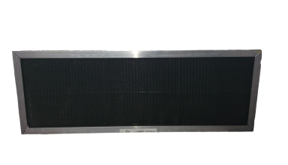**SARA NET FILTER**

Product Description: low resistance, can be cleared repeatedly,

long lifespan and cheap cost.

Application: Air Handling Units, Air Conditioning Units,

Special Acid and Alkali ventilation filters.

**Technical Specifications**

|  |  |
| --- | --- |
| Type | Panel |
| Media | Black nylon nets |
| Frame | Aluminum/G.I./Stainless steel/Rod Support |
| Optional aluminum | 10 ~ 46mm |
| Max. Temp. | 80 0C |

|  |  |  |  |
| --- | --- | --- | --- |
| Size  (L x W x T mm) | Airflow  (m3/h) | Initial DP  (Pa) | Filtering Area  (m2) |
| 592 X 592 X 10 | 3200 | 20 | 0.70 |
| 592 X 287 X 10 | 1560 | 20 | 0.34 |
| 592 X 490 X 10 | 2650 | 20 | 0.58 |
| 592 X 592 X 21 | 3200 | 20 | 0.70 |
| 592 X 287 X 21 | 1560 | 20 | 0.34 |
| 592 X 490 X 21 | 2650 | 20 | 0.58 |
| 295 X 295 X 10 | 799 | 20 | 0.17 |
| 495 X 295 X 10 | 1341 | 20 | 0.29 |
| 495 X 495 X 10 | 2249 | 20 | 0.49 |
| 595 X 295 X 10 | 1611 | 20 | 0.35 |
| 560 X 515 X 10 | 2648 | 20 | 0.58 |
| 295 X 295 X 21 | 799 | 20 | 0.17 |
| 495 X 295 X 21 | 1341 | 20 | 0.29 |
| 595 X 495 X 8 | 2704 | 20 | 0.59 |
| 595 X 595 X 8 | 3250 | 20 | 0.71 |

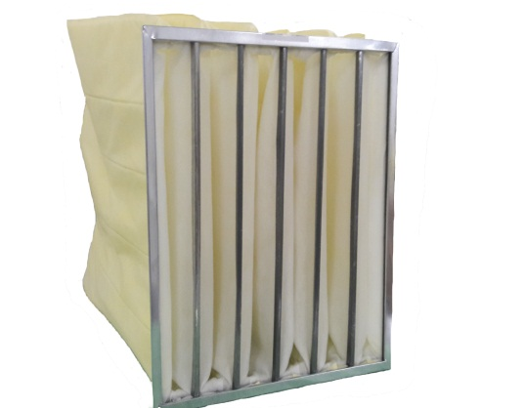**SYNTHETIC POCKET FILTER**

Product Description: Selection of optimized

V-shaped bag structure; low resistance; long lifespan;

superfine synthetic fiber; large dust holding capacity.

Application: Air handling units and general ventilation systems.

**Technical Specifications**

|  |  |
| --- | --- |
| Type | Pocket type: Ultrasonic bag |
| Media | Synthetic Fiber |
| Frame | Aluminum/G.I./stainless steel/plastic |
| Efficiency | 45% ~ 95% @ 0.5 microns |
| Class | F5 – F9 |
| Max. Temp. | 80 0C |
| Optional aluminum depth | 17 ~ 50 mm |
| Optional plastic frame | 21 mm |

|  |  |  |  |  |  |  |  |
| --- | --- | --- | --- | --- | --- | --- | --- |
| Size  (L x W x T mm) | Pockets | Airflow  (m3/h) | Initial DP  (Pa) | Final DP  (Pa) | Filtering Area  (m2) | Dust Holding Capacity (g) | Efficiency |
| 287 X 592 X 500 | 3 | 1400 | 50 | 250 – 300 | 2.10 | 377 | F5 |
| 287 X 592 X 500 | 3 | 1400 | 80 | 300 – 400 | 2.10 | 293 | F7 |
| 287 X 592 X 500 | 3 | 1400 | 120 | 400 – 450 | 2.10 | 230 | F9 |
| 592 X 592 X 500 | 3 | 1550 | 50 | 250 – 300 | 2.40 | 431 | F5 |
| 592 X 592 X 500 | 3 | 1550 | 80 | 300 – 400 | 2.40 | 335 | F7 |
| 592 X 592 X 500 | 3 | 1550 | 120 | 400 – 450 | 2.40 | 263 | F9 |
| 592 X 592 X 500 | 5 | 2330 | 50 | 250 – 300 | 3.60 | 647 | F5 |
| 592 X 592 X 500 | 5 | 2330 | 80 | 300 – 400 | 3.60 | 503 | F7 |
| 592 X 592 X 500 | 5 | 2330 | 120 | 400 – 450 | 3.60 | 395 | F9 |
| 592 X 592 X 500 | 6 | 2700 | 50 | 250 – 300 | 4.20 | 755 | F5 |
| 592 X 592 X 500 | 6 | 2700 | 80 | 300 – 400 | 4.20 | 587 | F7 |
| 592 X 592 X 500 | 8 | 3500 | 50 | 250 – 300 | 5.40 | 971 | F5 |
| 592 X 592 X 500 | 8 | 3500 | 80 | 300 – 400 | 5.40 | 755 | F7 |
| 592 X 592 X 500 | 8 | 3500 | 120 | 400 – 450 | 5.40 | 593 | F9 |
| 592 X 592 X 500 | 10 | 4270 | 50 | 250 – 300 | 6.60 | 1187 | F5 |
| 592 X 592 X 500 | 10 | 4270 | 80 | 300 – 400 | 6.60 | 923 | F7 |
| 592 X 592 X 500 | 10 | 4270 | 120 | 400 – 450 | 6.60 | 725 | F9 |

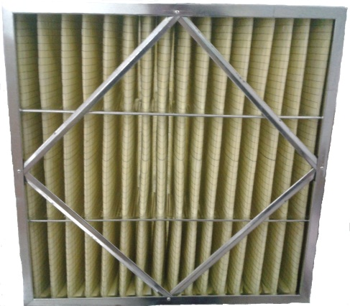**SECONDARY RIGID BOX FILTER**

Product Description: Box-type structure, large air volume,

solid architecture, large dust holding capacity

Application: Machinery, electronics, instrumentation,

food industry and general air conditioning.

**Technical Specifications**

|  |  |
| --- | --- |
| Type | Pleated |
| Media | Synthetic Fiber/Fiber Glass |
| Frame | G.I./Aluminum/Stainless Steel |
| Efficiency | 45% ~ 95% @ 0.5 microns |
| Max. Temp. | 80 0C |
| Optional | Single/Double Header Gasket |

|  |  |  |  |  |  |  |
| --- | --- | --- | --- | --- | --- | --- |
| Size  (L x W x T mm) | Airflow  (m3/h) | Initial DP  (Pa) | Final DP  (Pa) | Filtering Area  (m2) | Dust Holding Capacity (g) | Efficiency |
| 592 X 592 X 292 | 2890 | 50 | 250 – 300 | 4.46 | 803 | F5 |
| 592 X 592 X 292 | 2890 | 65 | 250 – 300 | 4.46 | 714 | F6 |
| 592 X 592 X 292 | 2890 | 80 | 300 – 400 | 4.46 | 625 | F7 |
| 592 X 592 X 292 | 2890 | 105 | 300 – 400 | 4.46 | 536 | F8 |
| 592 X 592 X 292 | 2890 | 120 | 400 – 450 | 4.46 | 491 | F9 |
| 287 X 592 X 292 | 1550 | 50 | 250 – 300 | 2.40 | 433 | F5 |
| 287 X 592 X 292 | 1550 | 65 | 250 – 300 | 2.40 | 385 | F6 |
| 287 X 592 X 292 | 1550 | 80 | 300 – 400 | 2.40 | 336 | F7 |
| 287 X 592 X 292 | 1550 | 105 | 300 – 400 | 2.40 | 288 | F8 |
| 287 X 592 X 292 | 1550 | 120 | 400 – 450 | 2.40 | 264 | F9 |
| 490 X 592 X 292 | 2440 | 50 | 250 – 300 | 3.78 | 680 | F5 |
| 490 X 592 X 292 | 2440 | 65 | 250 – 300 | 3.78 | 604 | F6 |
| 490 X 592 X 292 | 2440 | 80 | 300 – 400 | 3.78 | 529 | F7 |
| 490 X 592 X 292 | 2440 | 105 | 300 – 400 | 3.78 | 453 | F8 |

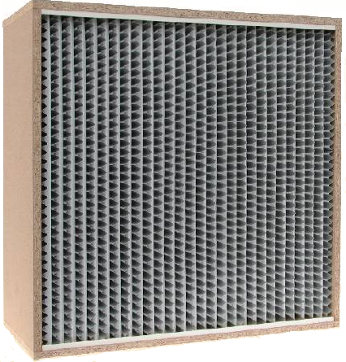**SECONDARY ALUMINUM**

**SEPARATOR FILTER**

Product Description: Box-type structure, large dust capacity

and maximize to use media.

Application: Air conditioning units and integrated air supply system

**Technical Specifications**

|  |  |
| --- | --- |
| Type | Pleated |
| Media | Micron polypropylene, Glass fiber |
| Frame | Aluminum/Galvanized/Stainless Steel/Wooden |
| Separator | 0.035mm aluminum foil |
| Efficiency | 65% ~ 95% @ 0.5 microns |
| Class | G4 |
| Max. Temp. | 80 0C |
| Optional | Single/Double Header Gasket, FaceGuard |

|  |  |  |  |  |  |  |
| --- | --- | --- | --- | --- | --- | --- |
| Size  (L x W x T mm) | Airflow  (m3/h) | Initial DP  (Pa) | Final DP  (Pa) | Filtering Area  (m2) | Dust Holding Capacity (g) | Efficiency |
| 610 X 610 X 292 | 3300 | 60 | 250 – 300 | 21.04 | 1262 | F6 |
| 610 X 610 X 292 | 3300 | 80 | 300 – 400 | 21.04 | 1262 | F7 |
| 610 X 610 X 292 | 3300 | 100 | 300 – 400 | 21.04 | 1262 | F8 |
| 610 X 610 X 292 | 3300 | 120 | 400 – 450 | 21.04 | 1262 | F9 |
| 915 X 610 X 292 | 4942 | 60 | 250 – 300 | 13.56 | 1893 | F6 |
| 915 X 610 X 292 | 4942 | 80 | 300 – 400 | 13.56 | 1893 | F7 |
| 915 X 610 X 292 | 4942 | 100 | 300 – 400 | 13.56 | 1893 | F8 |
| 915 X 610 X 292 | 4942 | 120 | 400 – 450 | 13.56 | 1893 | F9 |
| 1220 X 610 X 292 | 6590 | 60 | 250 – 300 | 42.08 | 2525 | F6 |
| 1220 X 610 X 292 | 6590 | 80 | 300 – 400 | 42.08 | 2525 | F7 |
| 1220 X 610 X 292 | 6590 | 100 | 300 – 400 | 42.08 | 2525 | F8 |
| 1220 X 610 X 692 | 6590 | 120 | 400 – 450 | 42.08 | 2525 | F9 |

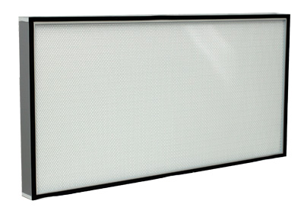**SECONDARY MINIPLEAT FILTER**

Product Description: Small volume, light weight,

easy to install, stable efficiency, uniform wind speed.

Application: Central air conditioning and integrated

air supply system.

**Technical Specifications**

|  |  |
| --- | --- |
| Type | Pleated |
| Media | Domestic/import High-humidity resistance Glass fiber |
| Frame | Aluminum/Galvanized/Stainless steel/plastic |
| Face guard | Spray diamond mesh |
| Efficiency | 65% ~ 95% @ 0.5 micron |
| Class | G4 |
| Optional | Faceguard, Gasket |

|  |  |  |  |  |  |  |
| --- | --- | --- | --- | --- | --- | --- |
| Size  (L x W x T mm) | Airflow  (m3/h) | Initial DP  (Pa) | Final DP  (Pa) | Filtering Area  (m2) | Dust Holding Capacity (g) | Efficiency |
| 610 X 610 X 96 | 2360 | 60 | 250 – 300 | 16.20 | 972 | F6 |
| 610 X 610 X 96 | 2360 | 80 | 300 – 400 | 16.20 | 972 | F7 |
| 610 X 610 X 96 | 2360 | 100 | 300 – 400 | 16.20 | 972 | F8 |
| 610 X 610 X 96 | 2360 | 120 | 400 – 450 | 16.20 | 972 | F9 |
| 915 X 610 X 96 | 3500 | 60 | 250 – 300 | 24.04 | 1443 | F6 |
| 915 X 610 X 96 | 3500 | 80 | 300 – 400 | 24.04 | 1443 | F7 |
| 915 X 610 X 96 | 3500 | 100 | 300 – 400 | 24.04 | 1443 | F8 |
| 915 X 610 X 96 | 3500 | 120 | 400 – 450 | 24.04 | 1443 | F9 |
| 1220 X 610 X 96 | 4650 | 60 | 250 – 300 | 31.89 | 1913 | F6 |
| 1220 X 610 X 96 | 4650 | 80 | 300 – 400 | 31.89 | 1913 | F7 |
| 1220 X 610 X 96 | 4650 | 100 | 300 – 400 | 31.89 | 1913 | F8 |
| 1220 X 610 X 96 | 4650 | 120 | 400 – 450 | 31.89 | 1913 | F9 |

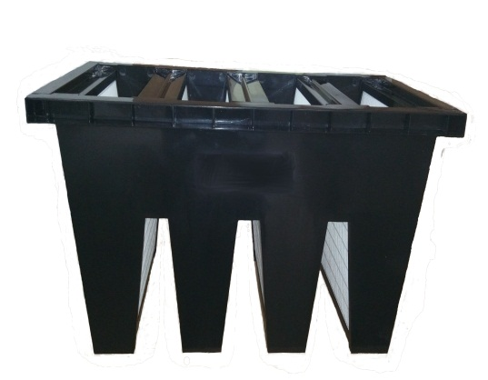**SECONDARY V-BANK FILTER**

Product Description: Large filtration area, and large

airflow capacity and large dust holding capacity.

Application: Air Handling Units, Offices, Buildings

Industrial and Clean Room Applications

**Technical Specifications**

|  |  |
| --- | --- |
| Type | 3 to 6 banks |
| Media | Domestic/import High-humidity resistance Glass fiber |
| Frame | Galvanized frame/Aluminum/Plastic |
| Separator | Hot melt bead |
| Efficiency | 65% ~ 95% @ 0.5 microns |
| Max. Temp. | 70 0C |
| Optional | Single/Double header/Box type Gasket |

|  |  |  |  |  |  |  |  |
| --- | --- | --- | --- | --- | --- | --- | --- |
| Size  (L x W x T mm) | Packs | Airflow  (m3/h) | Initial DP  (Pa) | Final DP  (Pa) | Filtering Area  (m2) | Dust Holding Capacity (g) | Efficiency |
| 592 X 592 X 292 | 3 | 2660 | 120 | 300 – 400 | 16.43 | 986 | F7 |
| 592 X 592 X 292 | 4 | 3550 | 120 | 300 – 400 | 21.91 | 1315 | F7 |
| 610 X 610 X 292 | 5 | 4570 | 120 | 300 – 400 | 28.20 | 1692 | F7 |
| 592 X 592 X 292 | 3 | 2660 | 150 | 300 – 400 | 16.43 | 986 | F8 |
| 592 X 592 X 292 | 4 | 3550 | 150 | 300 – 400 | 21.91 | 1315 | F8 |
| 610 X 610 X 292 | 5 | 4570 | 150 | 300 – 400 | 28.2 | 1692 | F8 |
| 592 X 592 X 292 | 3 | 2660 | 180 | 400 – 450 | 16.43 | 986 | F9 |
| 592 X 592 X 292 | 4 | 3550 | 180 | 400 – 450 | 21.91 | 1315 | F9 |
| 610 X 610 X 292 | 5 | 4570 | 180 | 400 – 450 | 28.20 | 1692 | F9 |
| 287 X 287 X 292 | 2 | 880 | 120 | 300 – 400 | 5.45 | 327 | F7 |
| 610 X 305 X 292 | 5 | 2340 | 120 | 300 – 400 | 14.44 | 866 | F7 |
| 592 X 287 X 292 | 4 | 1760 | 120 | 300 – 400 | 10.90 | 654 | F7 |
| 287 X 592 X 292 | 3 | 2660 | 150 | 300 – 400 | 16.43 | 986 | F8 |
| 305 X 610 X 292 | 3 | 2740 | 150 | 300 – 400 | 16.92 | 1015 | F8 |

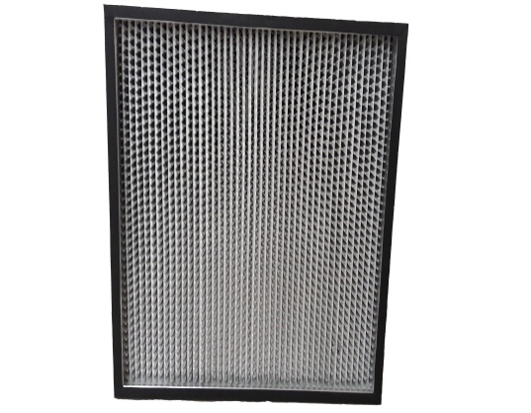**HEPA ALUMINUM SEPARATOR FILTER**

Product Description: Uses Pleated Aluminum partition

to maintain even pleat spacing. Available in standard

or compact type (high capacity)

Application: Purifying air conditioning system,

local purification equipment, clean room and

industrial applications

**Technical Specifications**

|  |  |
| --- | --- |
| Type | Pleated with Aluminum Separator |
| Media | Glass fiber |
| Frame | Aluminum/galvanized/stainless steel/Particle board |
| Separator | 120 g/m3 paper or 0.035mm aluminum foil |
| Efficiency | 99.99% ~ 99.995% @ 0.3 microns |
| Max. Temp. | 80 0C |
| Optional | Faceguard, Gasket |

|  |  |  |  |  |  |  |
| --- | --- | --- | --- | --- | --- | --- |
| Size  (L x W x T mm) | Airflow  (m3/h) | Initial DP  (Pa) | Final DP  (Pa) | Filtering Area  (m2) | Dust Holding Capacity (g) | Efficiency |
| 610 X 610 X 120 | 620 | 220 | 400 – 600 | 7.1 | 370 | H13 ~ H14 |
| 915 X 610 X 120 | 930 | 220 | 400 – 600 | 10.6 | 560 | H13 ~ H14 |
| 1220 X 610 X 120 | 1500 | 220 | 400 – 600 | 14.1 | 740 | H13 ~ H14 |
| 610 X 610 X 150 | 1000 | 220 | 400 – 600 | 9.7 | 510 | H13 ~ H14 |
| 915 X 610 X 150 | 1500 | 220 | 400 – 600 | 14.5 | 770 | H13 ~ H14 |
| 1220 X 610 X 150 | 2000 | 220 | 400 – 600 | 19.3 | 1020 | H13 ~ H14 |
| 610 X 610 X 220 | 1600 | 220 | 400 – 600 | 15.8 | 920 | H13 ~ H14 |
| 915 X 610 X 220 | 2300 | 220 | 400 – 600 | 23.7 | 1340 | H13 ~ H14 |
| 1220 X 610 X 220 | 3000 | 220 | 400 - 600 | 31.6 | 1750 | H13 ~ H14 |

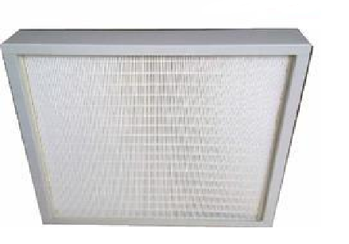

**HEPA MINIPLEAT FILTER**

Product Description: Maximizes filter surface area,

maintains even air flow with high air purity.

Application: often used for clean rooms,

fan filter units, hospitals, etc.

**Technical Specifications**

|  |  |
| --- | --- |
| Type | Pleated |
| Media | Glass Fiber |
| Frame | Aluminum/Galvanized/Stainless Steel/plastic |
| Separator | Hot melt bead |
| Efficiency | 99.99% ~ 99.9995% @ 0.3 microns |
| Max. Temp. | 70 0C |
| Optional | Faceguard, Gasket |

|  |  |  |  |  |  |  |
| --- | --- | --- | --- | --- | --- | --- |
| Size  (L x W x T mm) | Airflow  (m3/h) | Initial DP  (Pa) | Final DP  (Pa) | Filtering Area  (m2) | Dust Holding Capacity (g) | Efficiency |
| 305 X 305 X 50 | 200 | 200 | 400 – 600 | 1.8 | 100 | H13 ~ H14 |
| 484 X 484 X 50 | 500 | 200 | 400 – 600 | 4.6 | 300 | H13 ~ H14 |
| 610 X 610 X 50 | 800 | 200 | 400 – 600 | 7.5 | 450 | H13 ~ H14 |
| 915 X 610 X 50 | 1200 | 200 | 400 – 600 | 11.2 | 700 | H13 ~ H14 |
| 1220 X 610 X 50 | 1600 | 200 | 400 – 600 | 14.9 | 900 | H13 ~ H14 |
| 305 X 305 X 69 | 260 | 200 | 400 – 600 | 2.5 | 150 | H13 ~ H14 |
| 484 X 484 X 69 | 700 | 200 | 400 – 600 | 6.6 | 400 | H13 ~ H14 |
| 610 X 610 X 69 | 1000 | 200 | 400 – 600 | 10.7 | 650 | H13 ~ H14 |
| 915 X 610 X 69 | 1500 | 200 | 400 – 600 | 16.0 | 950 | H13 ~ H14 |
| 1220 X 610 X 69 | 2100 | 200 | 400 – 600 | 21.3 | 1000 | H13 ~ H14 |
| 610 X 610 X 90 | 1500 | 200 | 400 – 600 | 14.9 | 900 | H13 ~ H14 |
| 915 X 610 X 90 | 2000 | 200 | 400 – 600 | 22.3 | 1200 | H13 ~ H14 |
| 1220 X 610 X 69 | 2800 | 200 | 400 – 600 | 29.8 | 1800 | H13 ~ H14 |

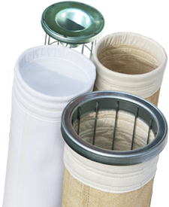

**FILTER BAGS**

Product Description: Standard and custom-made filter bags to meet the specifications of OEM dust collectors for different industrial applications. These are used for pollution and dust control, liquid/solid separation and product recovery.

Application: Cement, Chemical, Food Processing, Minerals, Feed and Oil Refining

Also available: Connector Sleeves, Felt Cloth, Filter Cage, Pleated Cartridge Filter

**Technical Specifications**

**Filter fabrics**

GHII filter bags are manufactured using high quality media, including wide range of woven needle felt and fabrics such as Polyester, Polypropylene, Nomex and PTFE. Different finishing treatments are available to improve filtration and enhance physical and chemical characteristics such as flame retardation, water and oil repellent quality and increased chemical resistance.

## Common Needle Punched Felt

# Polyester Needle Punched Felt

|  |  |
| --- | --- |
| Product name | Polyester Needle Punched Felt |
| Composition | Polyester Fiber |
| Weight (g/㎡) | 500 |
| Thickness (mm) | 1.80 |
| Tensile Strength (n/5X10cm) | Warp: ≥1000 weft: ≥1100 |
| Tensile Elongation (%) | Warp: ≤35 weft: ≤40 |
| Air Permeability ( L/ M2.S) | 330-350 |
| Temperature | Working temperature: 130  Short working temperature: 150 |
| Surface Treatment | Singeing, calendaring |

# Polypropylene Needle Punched Felt

|  |  |
| --- | --- |
| Product name | Polypropylene Needle Punched Felt |
| Composition | Polypropylene |
| Weight (g/㎡) | 500 |
| Thickness (mm) | 1.90 |
| Tensile Strength (n/5X10cm) | Warp: ≥1200 weft: ≥1250 |
| Tensile Elongation (%) | Warp: ≤50 weft: ≤55 |
| Air Permeability ( L/ M2.S) | 250-270 |
| Temperature | Working temperature: 90  Short working temperature: 110 |
| Surface Treatment | Singeing, calendaring |

## Special Needle Punched Felt

# Water & Oil repellent Needle Punched Felt

|  |  |
| --- | --- |
| Product name | Water & Oil repellent Needle Punched Felt |
| Composition | Polyester |
| Weight (g/㎡) | 500 |
| Thickness (mm) | 1.65 |
| Tensile Strength (n/5X10cm) | Warp: ≥1000 weft: ≥1100 |
| Tensile Elongation (%) | Warp: ≤35 weft: ≤40 |
| Air Permeability ( L/ M2.S) | 300-350 |
| Temperature | Working temperature: 130  Short working temperature: 150 |
| Surface Treatment | Calendering |

### Anti-static Needle Punched Felt

|  |  |
| --- | --- |
| Product name | Anti-static Needle Punched Felt |
| Composition | Polyester + Antistatic Lines |
| Weight (g/㎡) | 500 |
| Thickness (mm) | 1.80 |
| Tensile Strength (n/5X10cm) | Warp: ≥1000 weft: ≥1100 |
| Tensile Elongation (%) | Warp: ≤35 weft: ≤40 |
| Air Permeability ( L/ M2.S) | 175-185 |
| Temperature | Working temperature: 130  Short working temperature: 150 |
| Surface Treatment | Calendaring |

### Anti-static (Fiber) Needle Punched Felt

|  |  |
| --- | --- |
| Product name | Anti-static Needle Punched Felt |
| Composition | Polyester + Antistatic Fiber |
| Weight (g/㎡) | 500 |
| Thickness (mm) | 1.80 |
| Tensile Strength (n/5X10cm) | Warp: ≥1000 weft: ≥1100 |
| Tensile Elongation (%) | Warp: ≤35 weft: ≤40 |
| Air Permeability ( L/ M2.S) | 400-460 |
| Temperature | Working temperature: 130  Short working temperature: 150 |
| Surface Treatment | Singeing, calendaring |

## PPS Needle Punched Felt

|  |  |
| --- | --- |
| Product name | PPS Needle Punched Felt |
| material | PPS |
| Weight(g/㎡) | 500 |
| Thickness(mm) | 1.8 |
| Tensile strength (N/5×10cm) | Warp: 1250 Weft: 1350 |
| Tensile percentage(％) | Warp: <40 Weft: <60 |
| Air Permeability ( L/ M2.S) | 200-300 |
| Working Temperature(℃) | Continuance: 190 instant: 220 |
| Surface treatment | Singeing, Calendaring |

## Acrylic Needle Punched Felt

|  |  |
| --- | --- |
| Product name | Acylic needle punched felt |
| Composition | Acylic |
| Weight (g/㎡) | 500 |
| Thickness (mm) | 1.8 |
| Tensile Strength (n/5X10cm) | War: 1200 weft:1300 |
| Tensile Elongation (%) | Warp: <35 weft:< 40 |
| Air Permeability ( L/ M2.S) | 150-300 |
| Temperature | Continuance: 140 instant: 160 |
| Surface Treatment | Singeing, Calendaring |

## PTFE Coated Needle Punched Felt

|  |  |
| --- | --- |
| Product name | PTFE Coated needle punched felt |
| Composition | Polyster felt + PTFE Membrane |
| Weight (g/㎡) | 500 |
| Thickness (mm) | 1.8 |
| Tensile Strength (n/5X10cm) | War: 1200 weft:1350 |
| Tensile Elongation (%) | Warp: <17 weft:< 20 |
| Air Permeability ( L/ M2.S) | 30-40 |
| Temperature | Continuance: 130 instant: 160 |
| Surface Treatment | Singeing, PTFE Membrane |

# Aramid Needle Punched Felt (NOMEX)

|  |  |
| --- | --- |
| Item | Aramid Needle Punched Felt |
| material | Aramid fiber with Aramid scrim |
| Weight(g/㎡) | 500 |
| Thickness (mm) | 1.8 |
| Tensile strength (N/5×10cm) | Warp: 1300 Weft: 1460 |
| Tensile percentage(％) | Warp: <50 Weft: <55 |
| Air Permeability ( L/ M2.S) | 410-430 |
| Working Temperature(℃) | Continuance: 230 instant: 280 |
| Surface treatment | Singeing, heat setting |

**P84 Needle Punched Felt**

|  |  |
| --- | --- |
| Product name | P84 neede felt |
| Composition | P84 |
| Weight (g/㎡) | 500 |
| Thickness (mm) | 2.3 |
| Tensile Strength (n/5X10cm) | War: 700 weft:1200 |
| Tensile Elongation (%) | Warp: <35 weft:< 55 |
| Air Permeability ( L/ M2.S) | 15 |
| Temperature | Continuance: 260  Instant: 280 |
| Surface Treatment | Singeing, calendering |

**PTFE Needle Punched Felt**

|  |  |
| --- | --- |
| Product name | PTFE Felt |
| Composition | PTFE Felt + PTFE scrim |
| Weight (g/㎡) | 750 |
| Thickness (mm) | 1.1 |
| Tensile Strength (n/5X10cm) | War: 700 weft:950 |
| Tensile Elongation (%) | Warp: <27 weft:< 37 |
| Air Permeability ( L/ M2.S) | 18—21.6 |
| Temperature | Continuance: 260  Instant: 280 |
| Surface Treatment | Singeing, calendering |